Patrick Kevorkian

HW 7

Network Security

11/22/17

Lab 1

**4.1**

1-3. No screenshot needed

4.



5-6.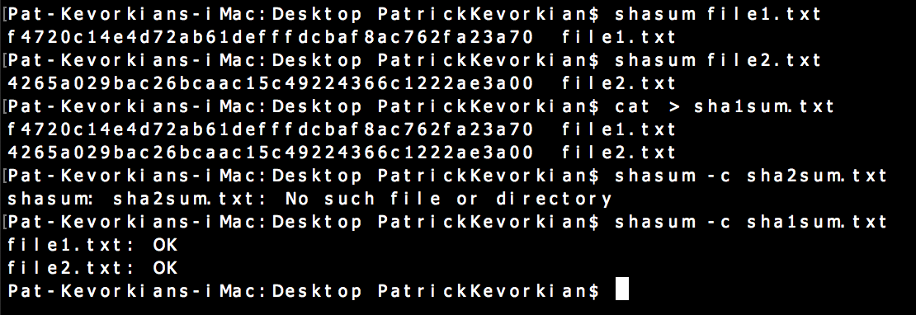

7.

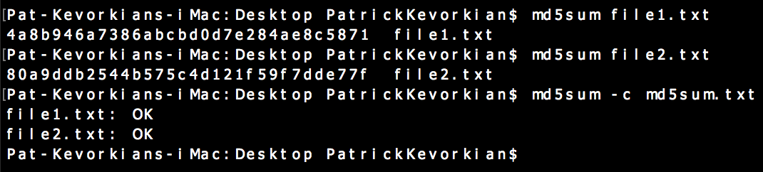

Questions:

1. Yes, length 32
2. Most of the time but not always there is a possibility of collision.
3. Sha1 hasn't been broken, and has a 160 bit output compare to md5 at 128 bit. Although I think recently google has broken Sha1, its much more difficult than md5.

**4.2**

1-6.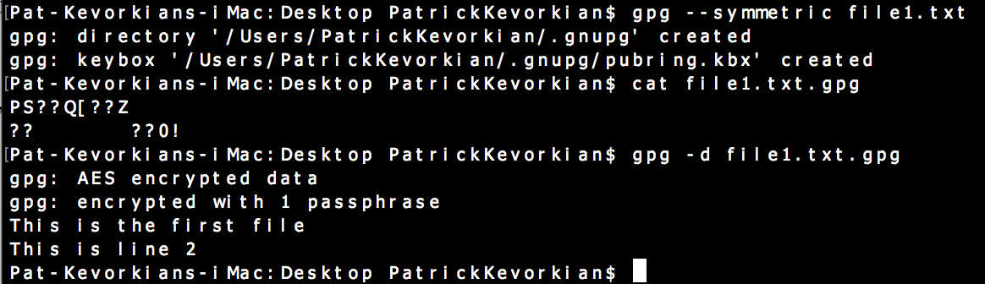

7-9.

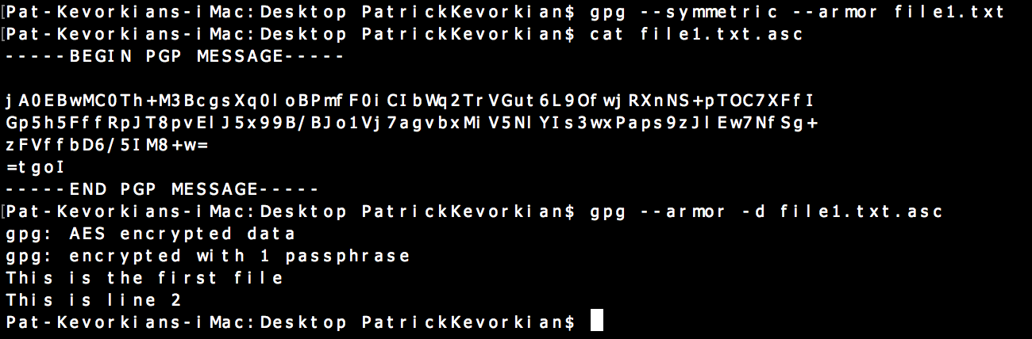

Questions:

4. Run “gpg --armor -d message.txt.asc” and enter the passphrase.

**4.3.2**

1.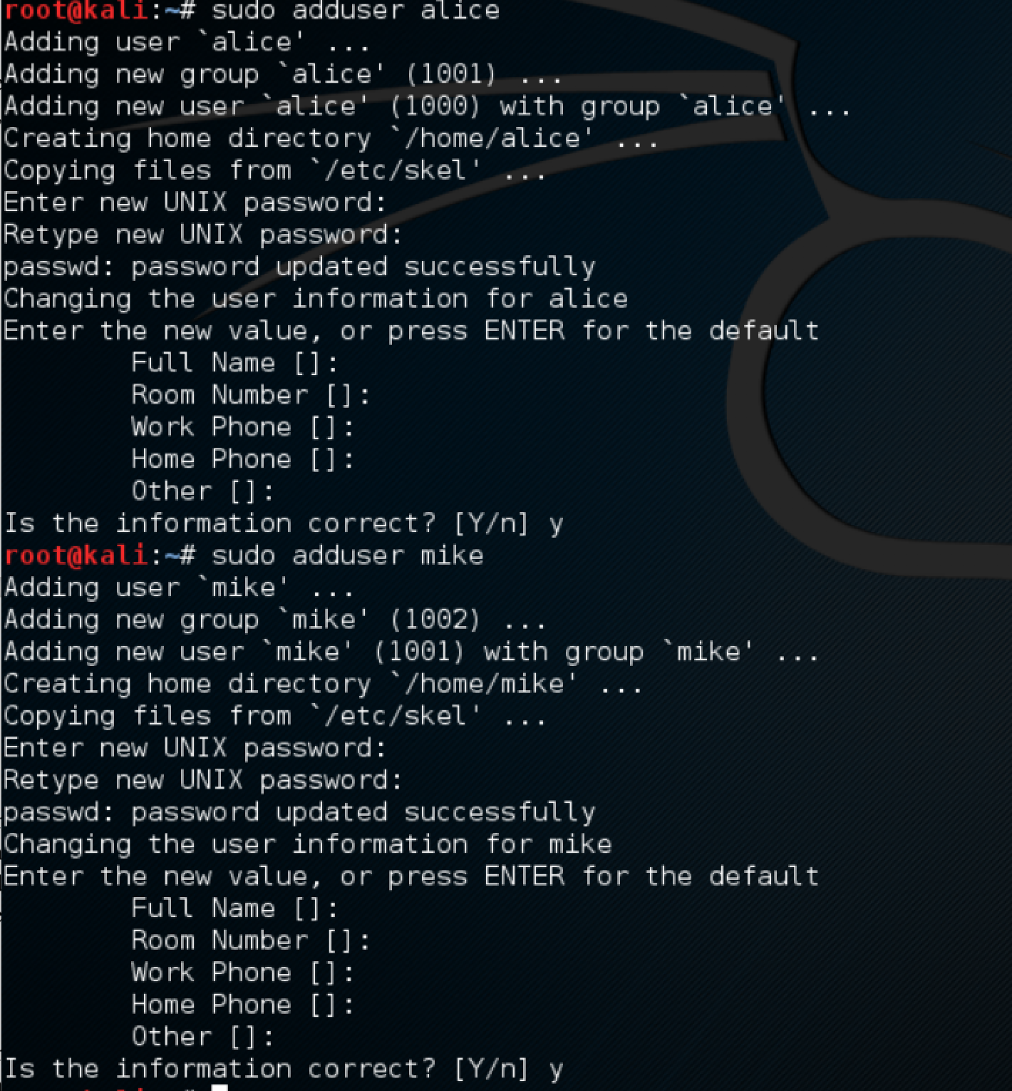

2.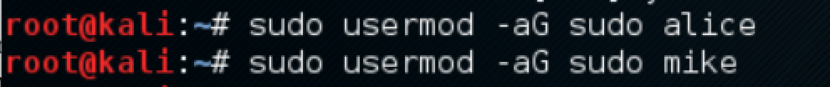

3.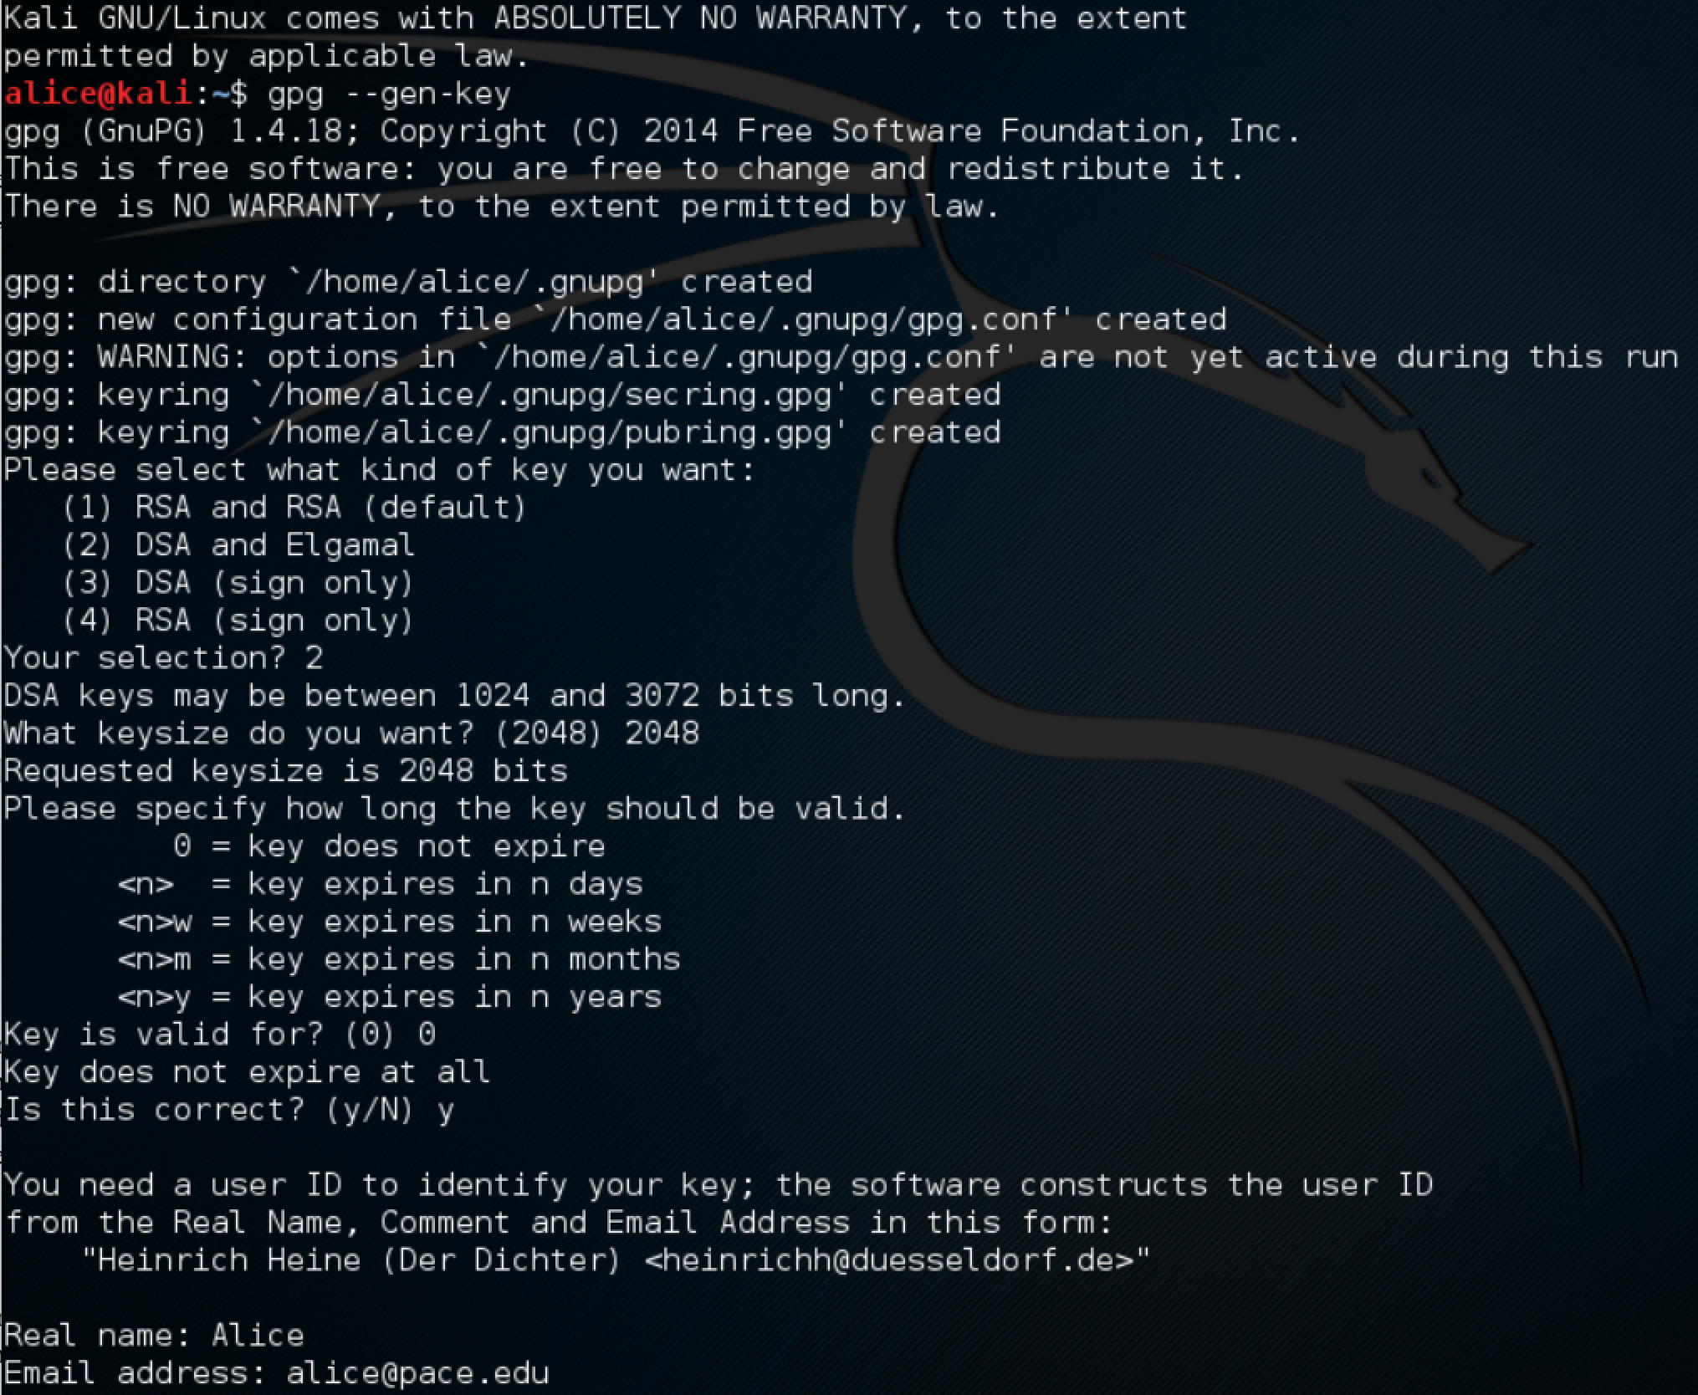

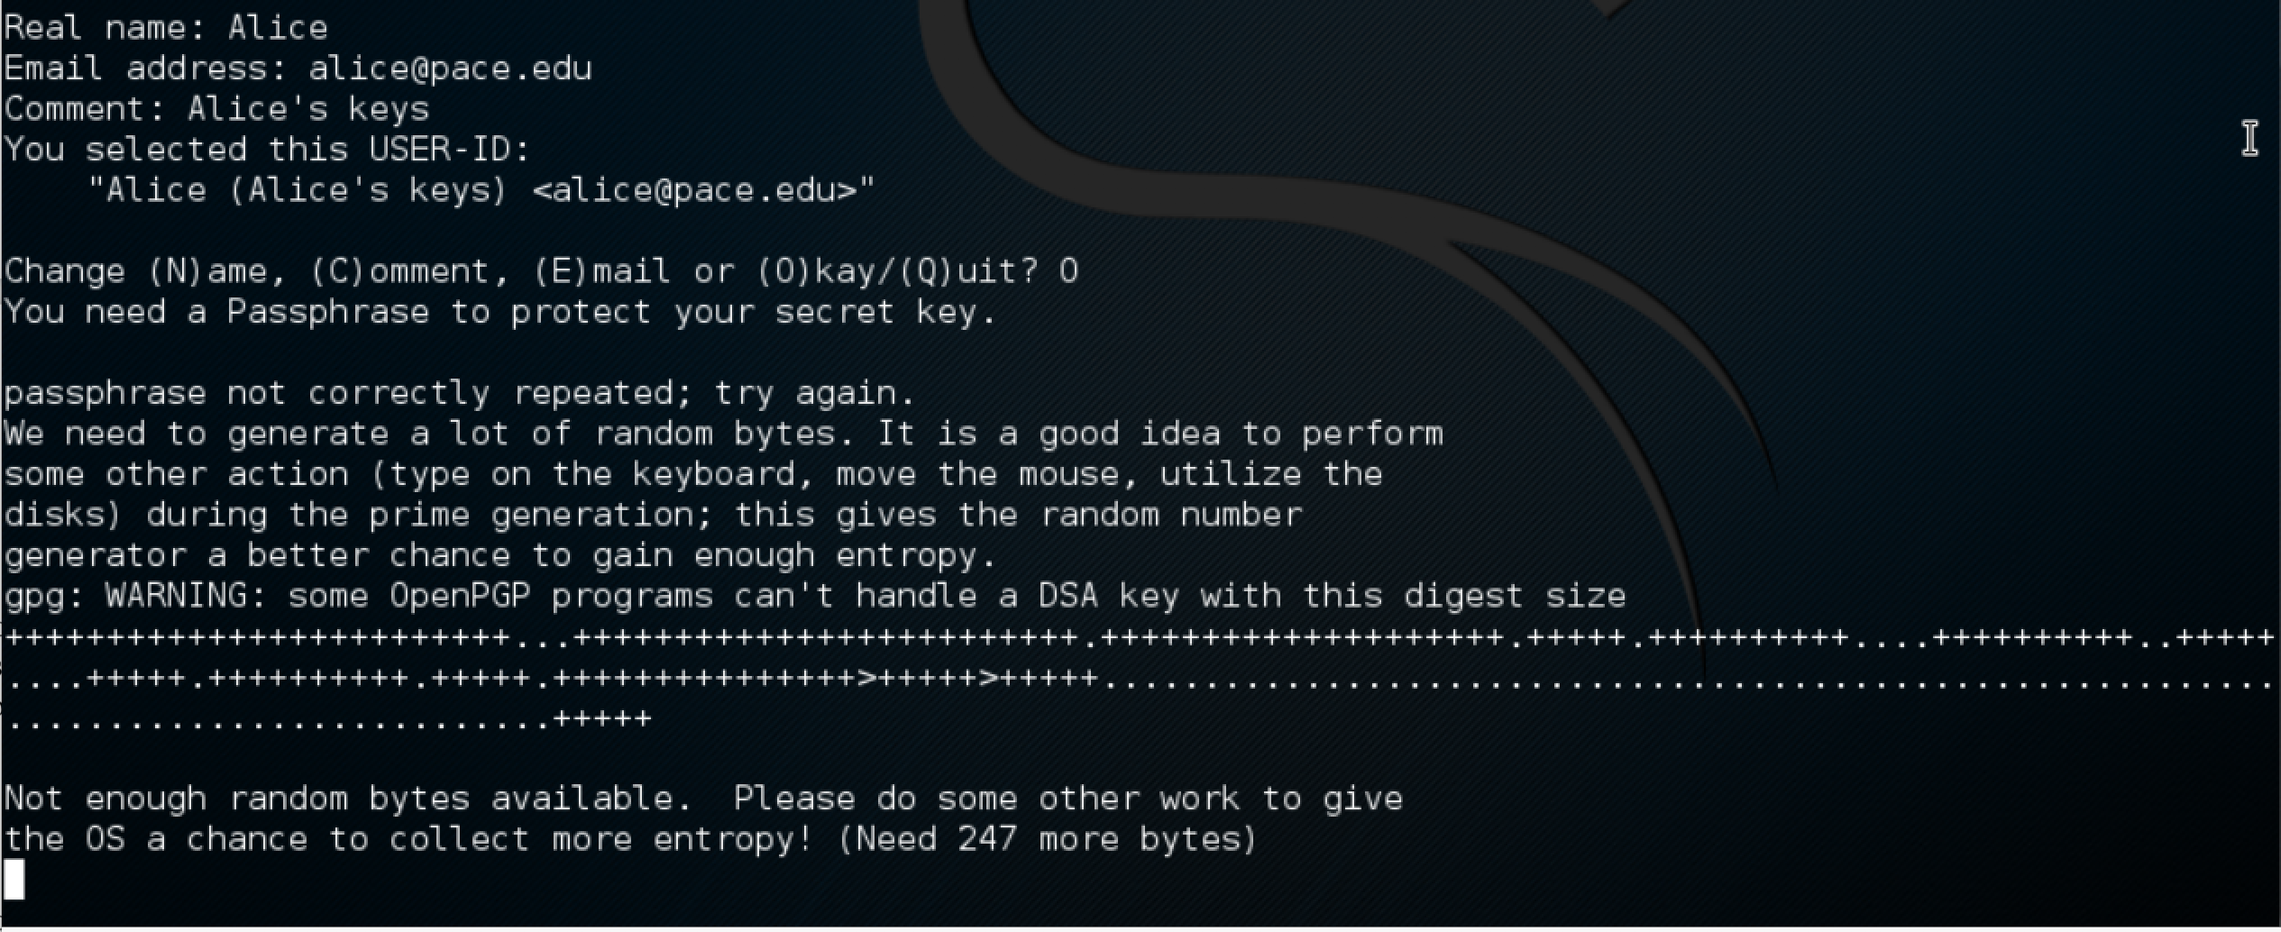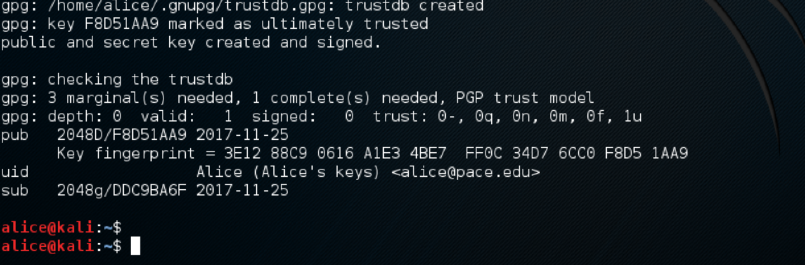4.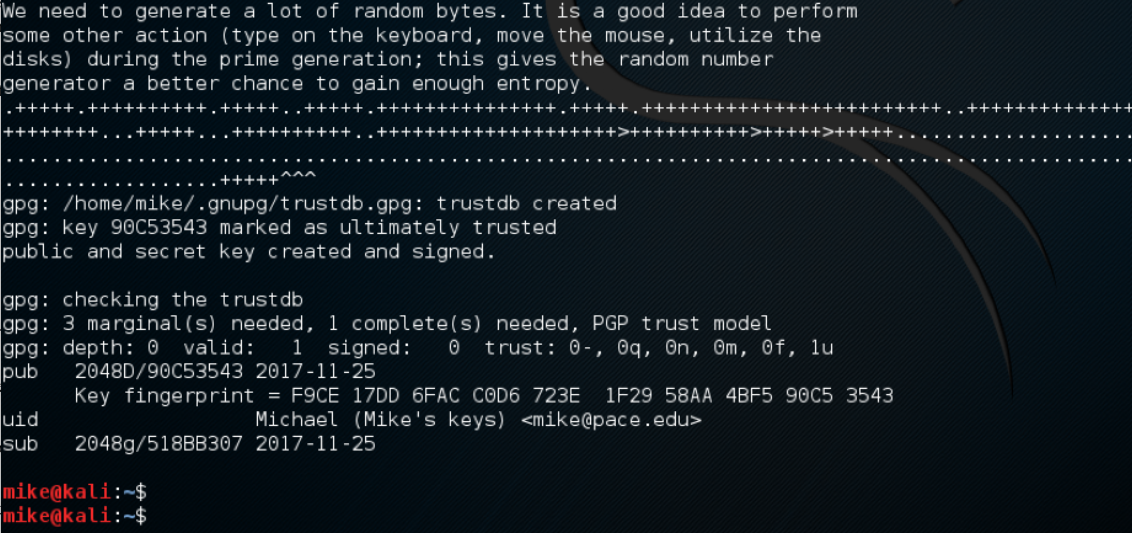

5.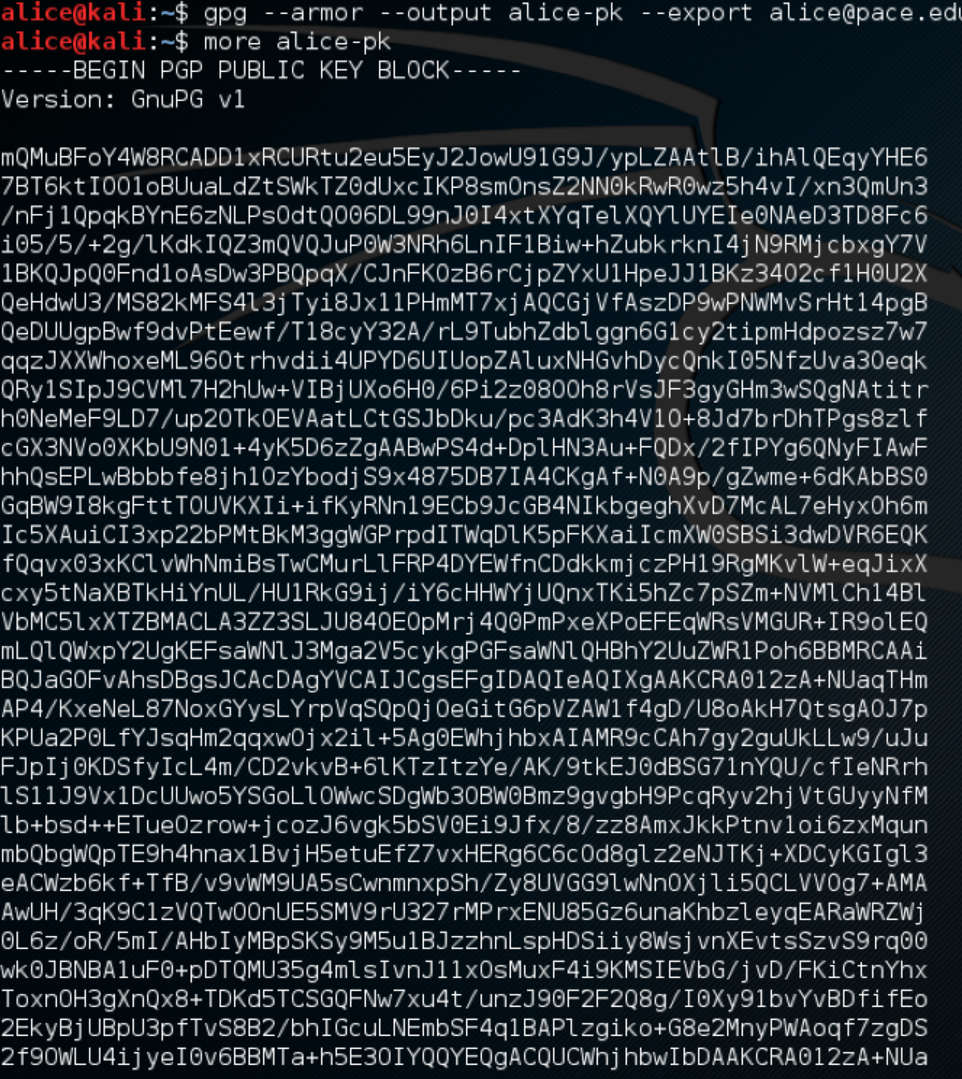

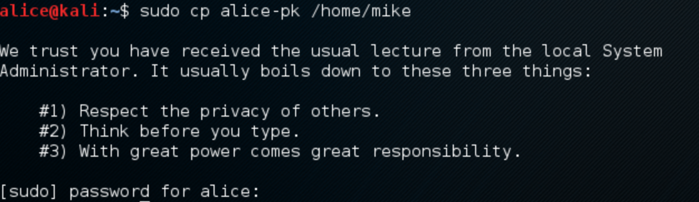



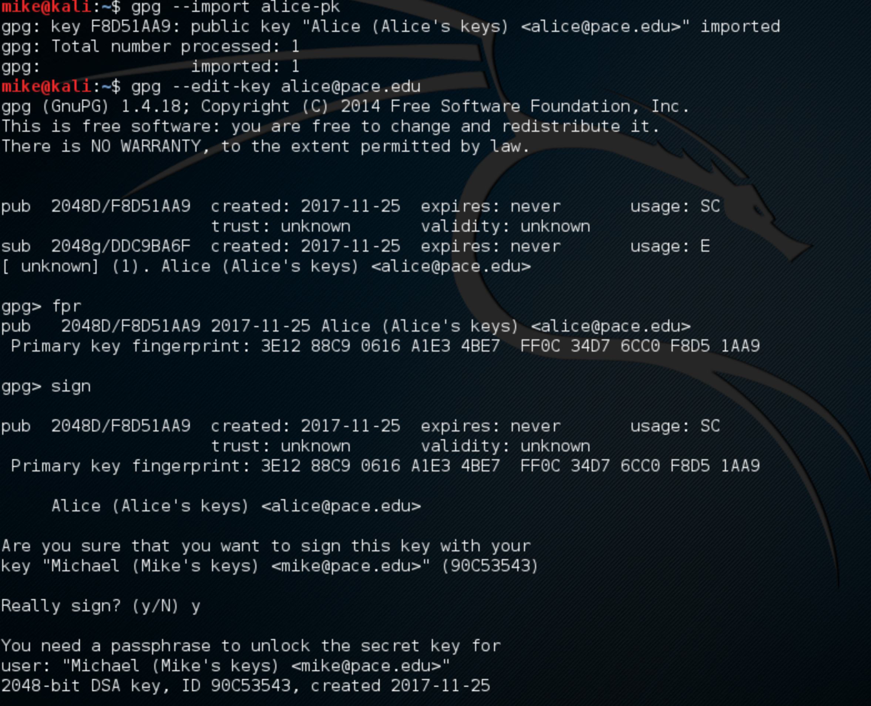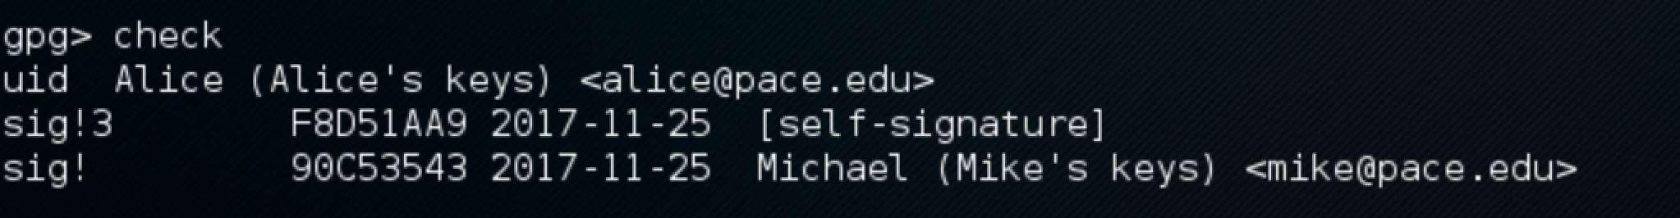



6.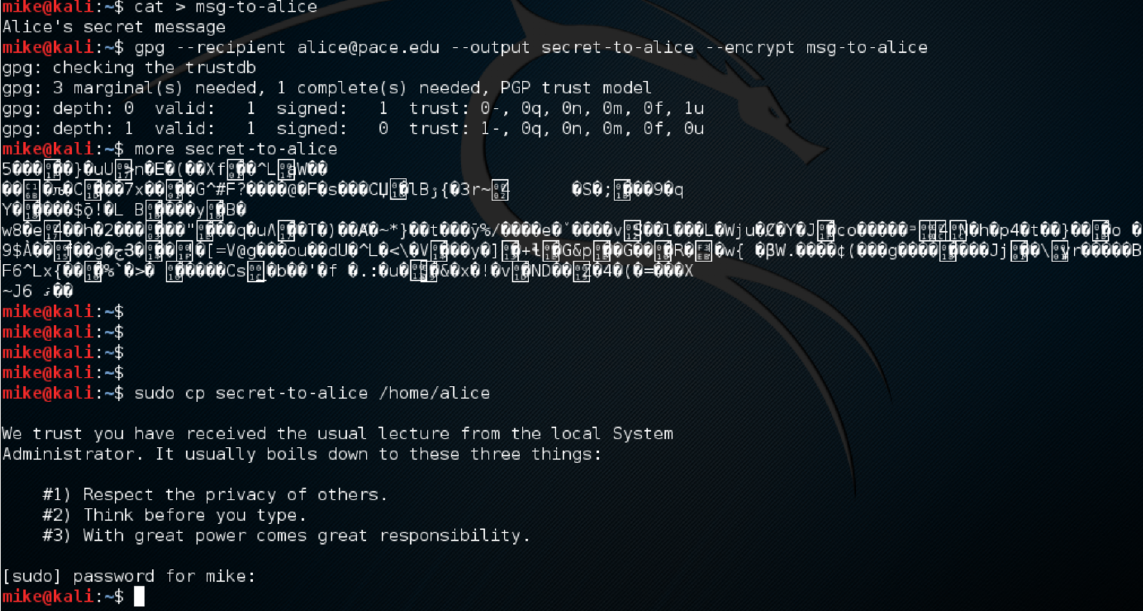

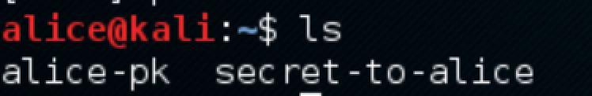

7.

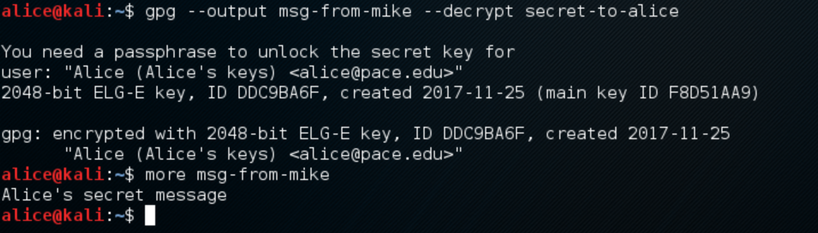

Questions:

5. Key servers, cloud.

6. Yes, but how do users know its your key?

7. Diffie-Hellman

8. Many ways, the message is encrypted.

9. Yes

10. Yes

11. No

Lab 2

**4.1**

1 - 2. TLS/SSL

3. AC Camerafirma S.A. , Atos

4.

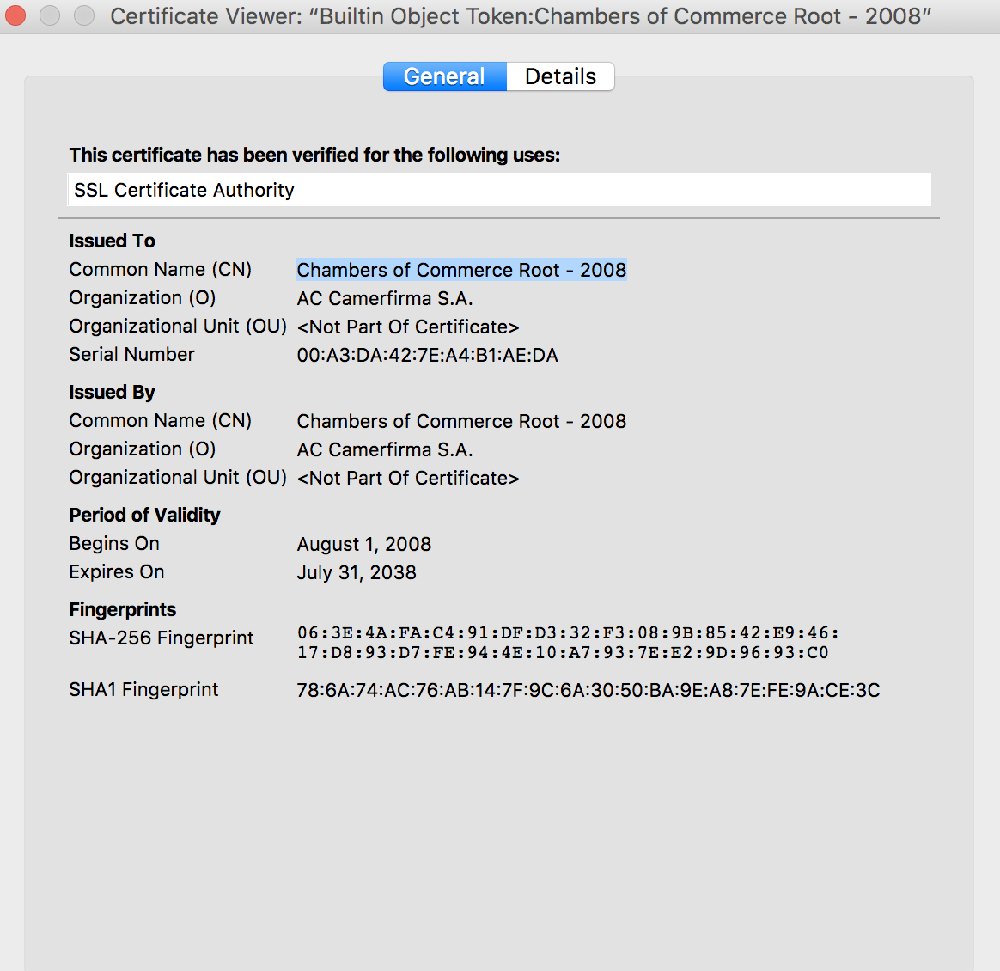

5. Sha1 with RSA encryption

6. 4096 bits

7. TLS

8. It Expired

**4.1 Creating Certificates**

1-5.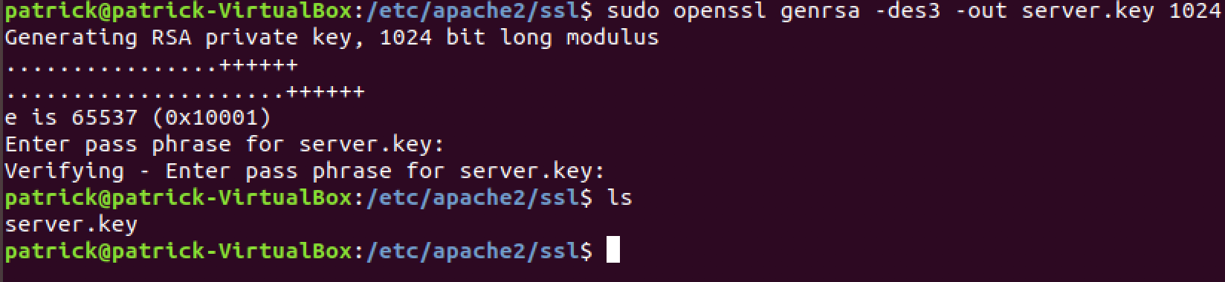

Passphrase: snapple

6-7.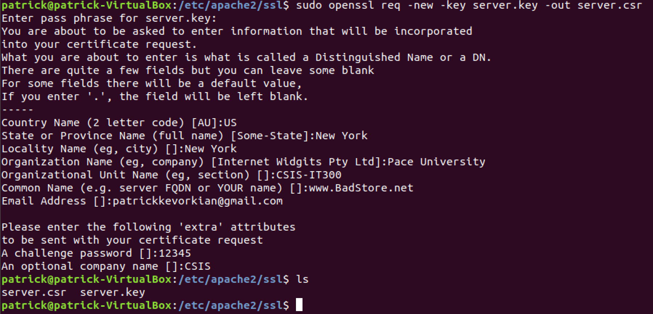

8-10

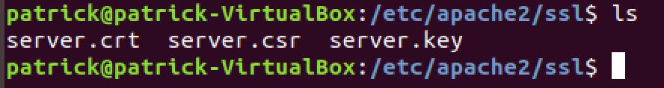

**4.2**

1-4.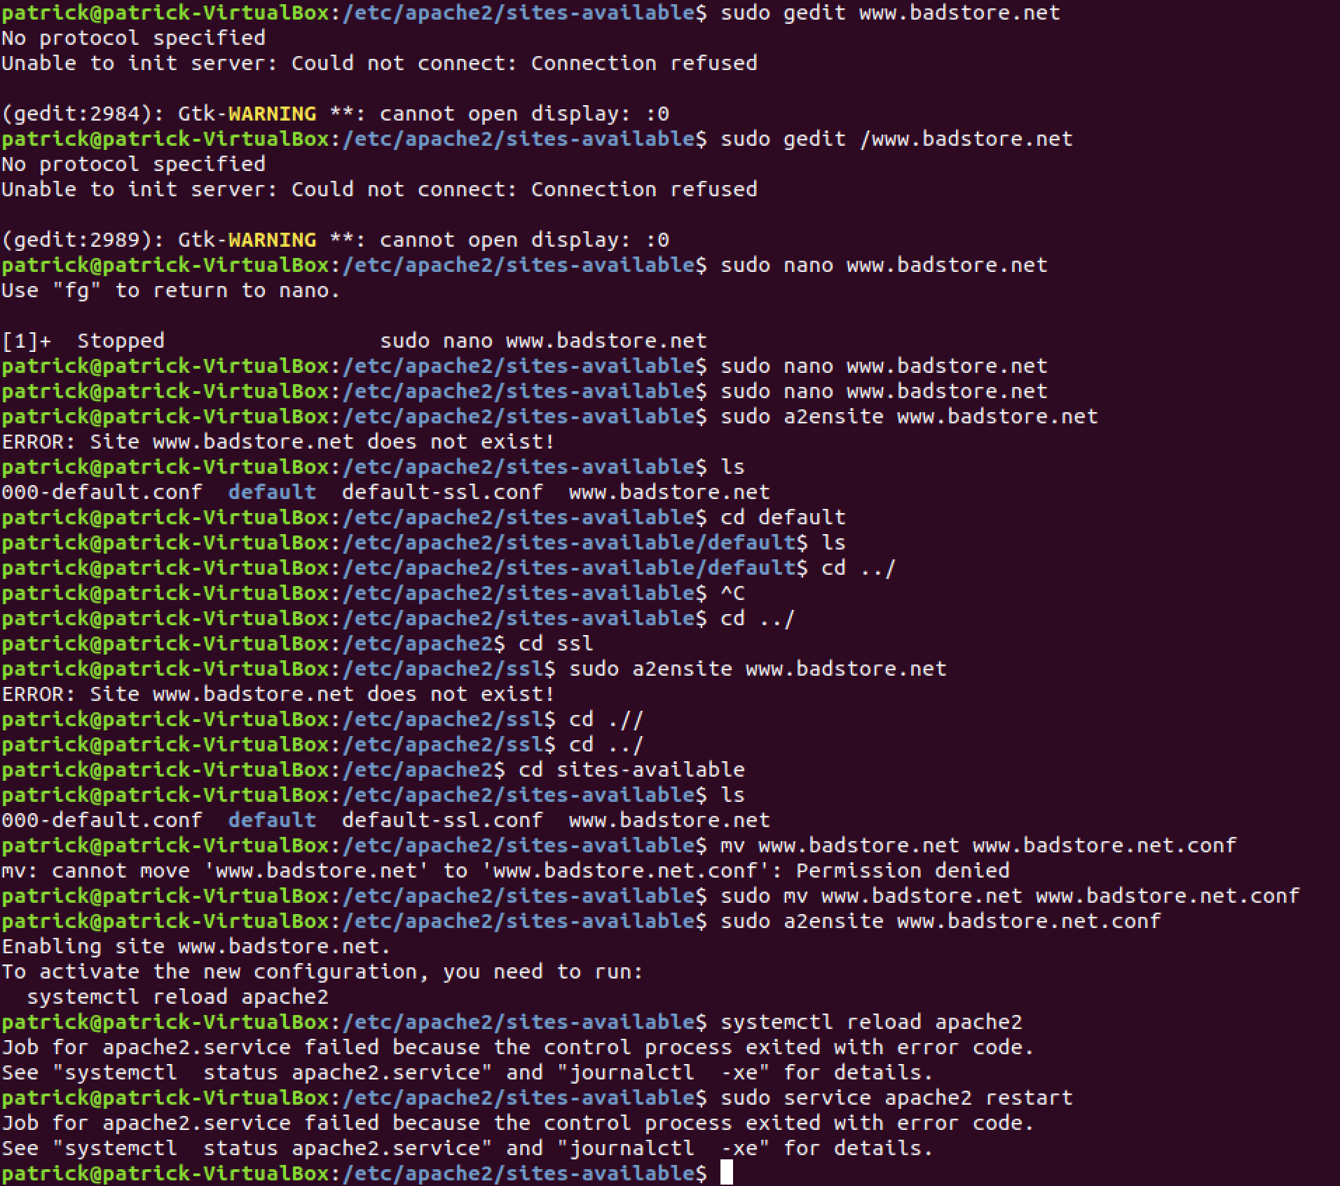

8-9.

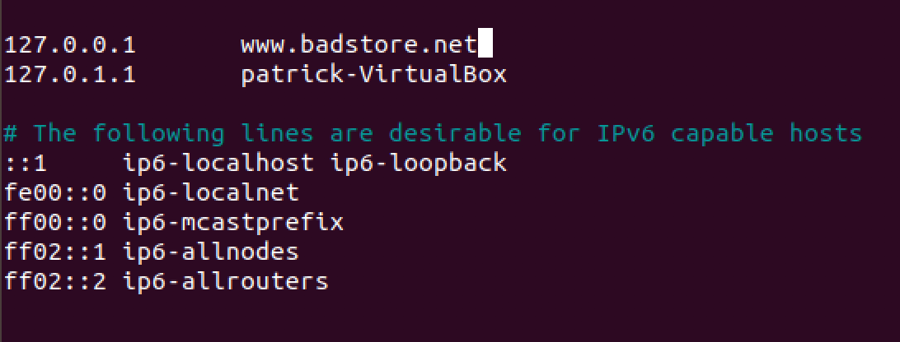

**4.3**

1-2

3-11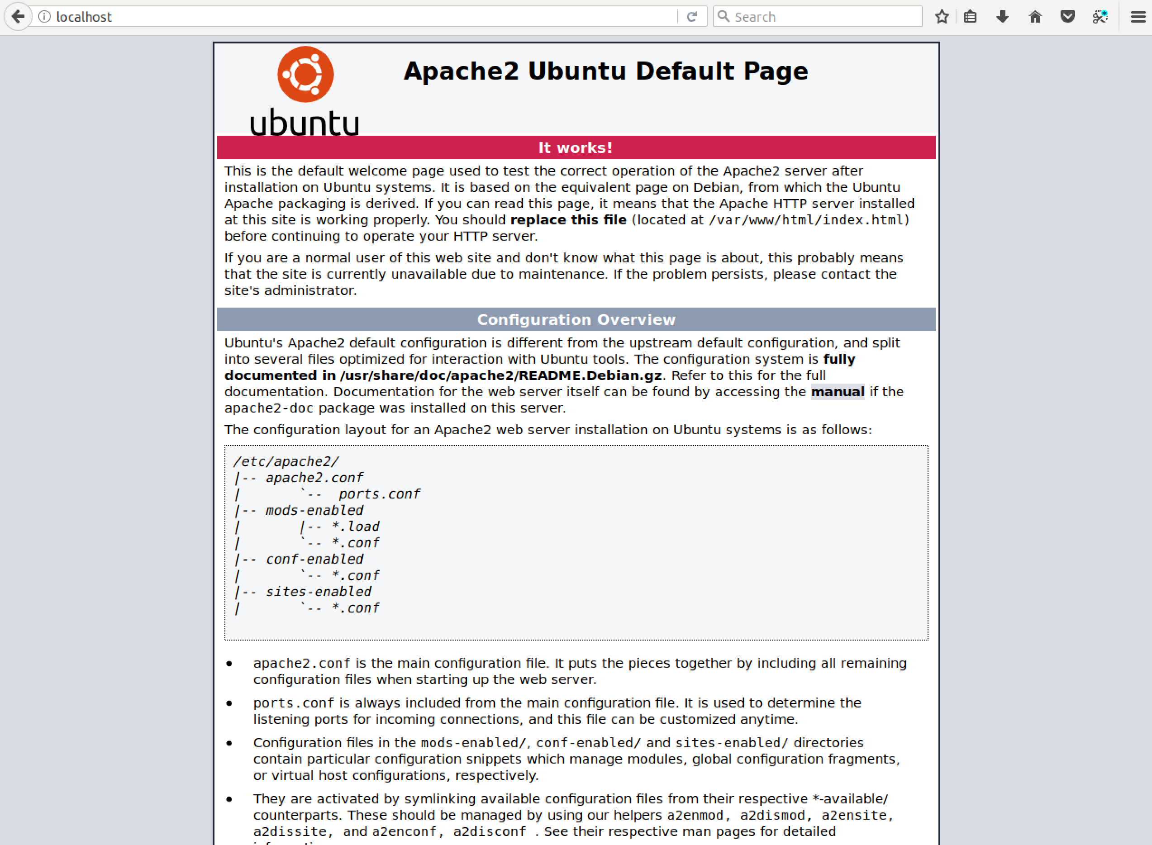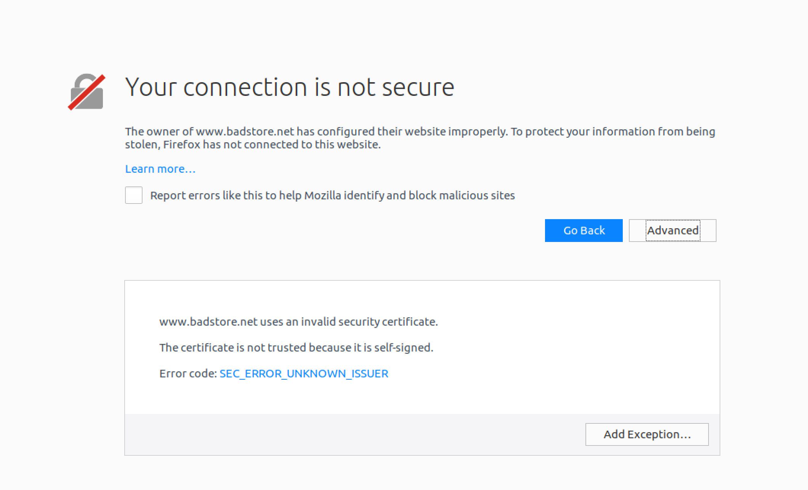

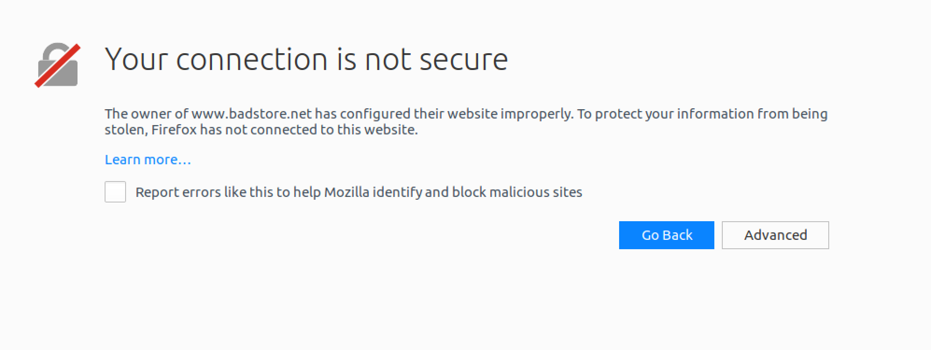

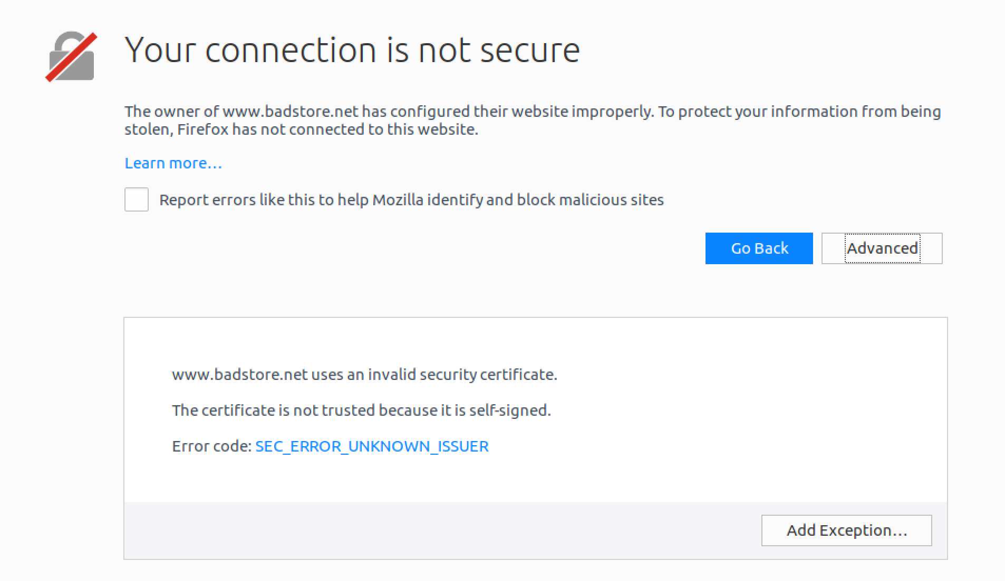

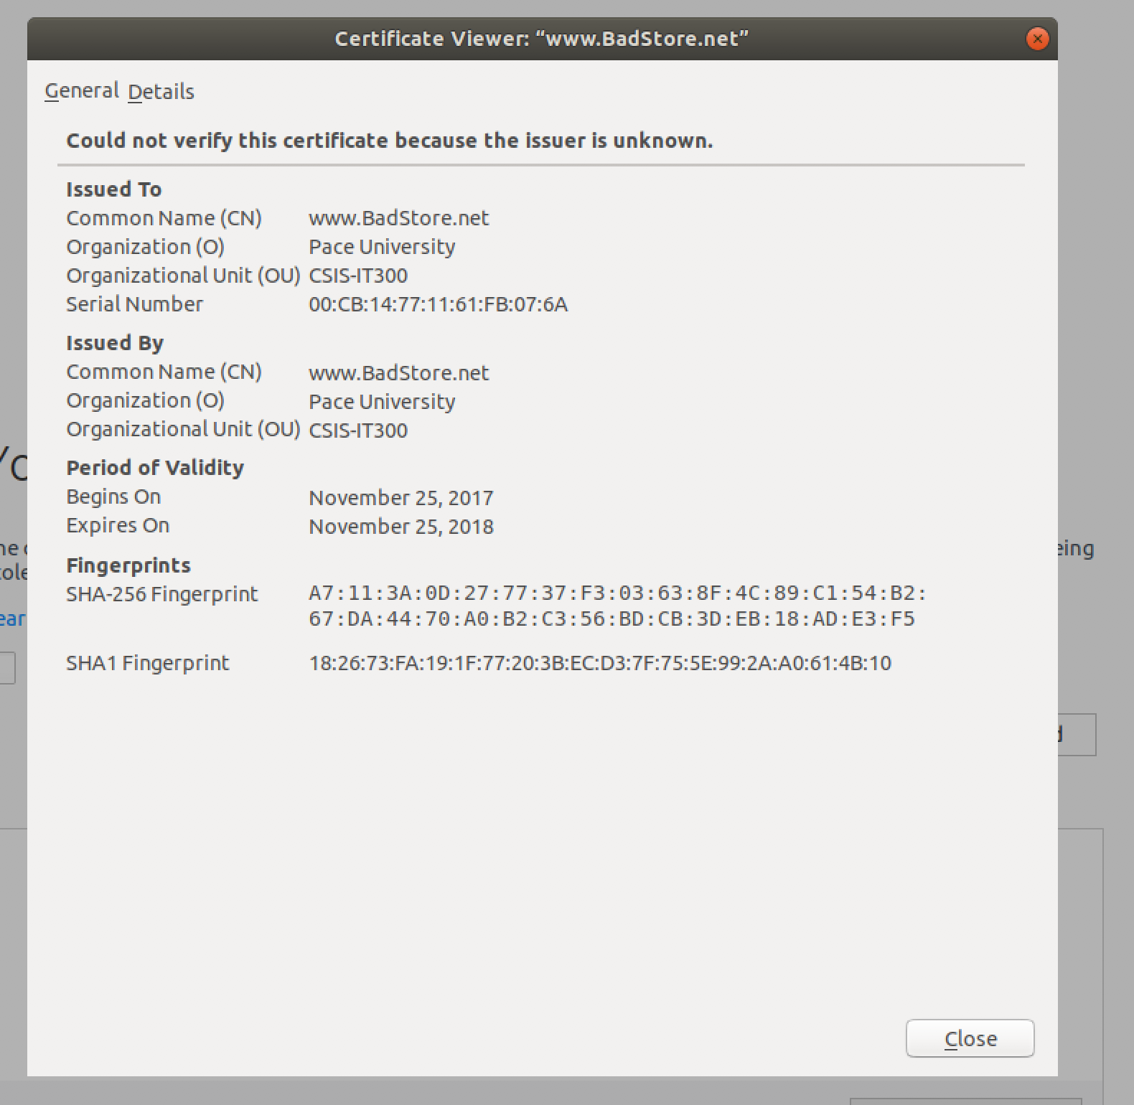

**4.4**

1.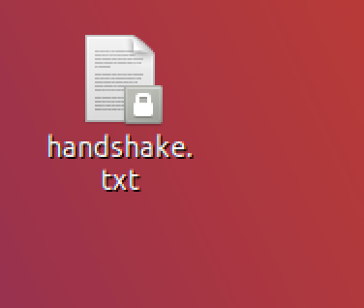

2.

